A000-Cyprus-Male figurine-Hooded-Terracotta-Cypro-Archaic II, ca 600–480 BCE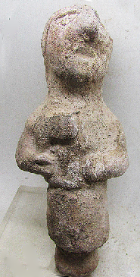 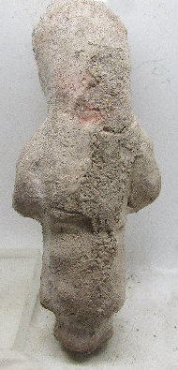

**Case no.: 3**

**Accession Number:**

**Formal Label:** Cyprus-Standing male figurine, Cypro-Archaic II, ca 600–480 BCE

**Display Description:**

This Cypriot terracotta is both wheel-made for the central columnar volume of the body and hand-made for distinguishing facial and upper body features. It represents a male with a hood and a long skirt holding the head of a halberd probably extolling this bronze weapon as a product that he made as a bronze-smith. His upwardly facing posture suggests that he is presenting the halberd as a gift. The figurine is solid terracotta, and it has a columnar plinth as its base, suggesting that it was once inserted into a plaque for presentation purposes. Palaepaphos, which was an ancient Cypriot bronze-making site and may have been associated with this terracotta.

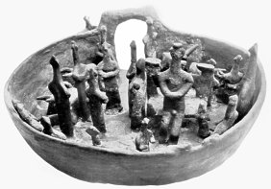 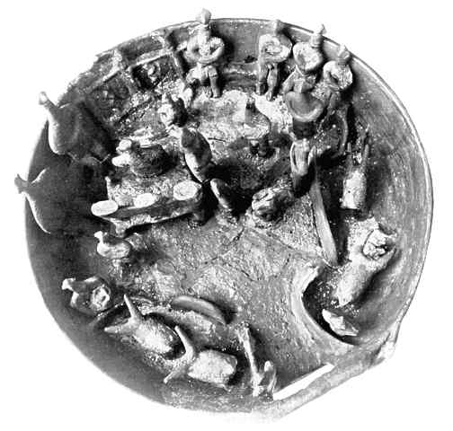 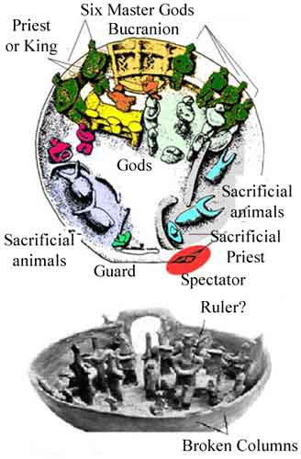

Fig. Terra cotta open air sanctuary model https://homepage.univie.ac.at/elisabeth.trinkl/forum/forum0300/pics/dosch03.jpg

Fig. https://homepage.univie.ac.at/elisabeth.trinkl/forum/forum0300/pics/dosch01.jpg

Later clay models of open air sanctuaries with figurines engaged in ritual ceremonies from Bellapais Vounous are well-known, and one such model is in the Nicosia Museum. This region may have been the setting from which this terracotta figure originated c 2000 BCE.

**LC Classification:** M5430

**Date or Time Horizon:** Cypro-Archaic II, ca 600–480 BCE

**Geographical Area:** Palaepaphos (?), Cyprus

**Map:**

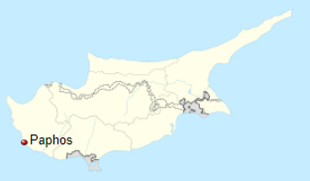

Map of Palaeopaphos which is near modern Paphos in Cyprus after https://upload.wikimedia.org/wikipedia/commons/thumb/2/21/Cyprus_location_map.svg/300px-Cyprus_location_map.svg.png

**GPS coordinates:** [34°46′N 32°25′E](https://tools.wmflabs.org/geohack/geohack.php?pagename=Paphos&params=34_46_N_32_25_E_region:CY_type:city(32892))

**Cultural Affiliation:** Cypro-Archaic II

**Medium:** terracotta

**Dimensions:** 111.86 mm, 4.40 in

**Weight: 111 gm, 3 1/8 oz**

**Condition: original**

**Provenance:**

**Discussion:**

The Cesnola Collection has many such figurines that are engaged in carrying objects for presentation.

**References:**

Karageorghis, Vassos ; Mertens, Joan R ; Rose, Marice E. 2000. [*Ancient art from Cyprus: the Cesnola collection in the Metropolitan Museum of Art*](https://buprimo.hosted.exlibrisgroup.com/primo-explore/fulldisplay?docid=ALMA_BOSU121654491540001161&context=L&vid=BU&lang=en_US&search_scope=default_scope&adaptor=Local%20Search%20Engine&tab=default_tab&query=lsr08,contains,42780631&sortby=rank)*.* New York: Metropolitan Museum of Art.

Merrillees Robert Stuart. 2012. 1. Giorgos Georgiou, Jennifer M. Webb, David Frankel, Psematismenos- Trelloukkas, An Early Bronze Age Cemetery in Cyprus. In: Cahiers du Centre d'Etudes Chypriotes. Volume 42, 2012. pp. 479-487.